|  |  |
| --- | --- |
|  | *“In Pursuit of Global Competitiveness”*  **GOVERNMENT COLLEGE OF ENGINEERING, Aurangabad,**  **CHHATRAPATI SAMBHAJINAGAR**  (An Autonomous Institute of Government of Maharashtra)  Station Road, Osmanpura Aurangabad 431005 (Maharashtra State)  Phone: 0240 - 2366 350, 2366 346, 2366345 Web Site: www.geca.ac.in |

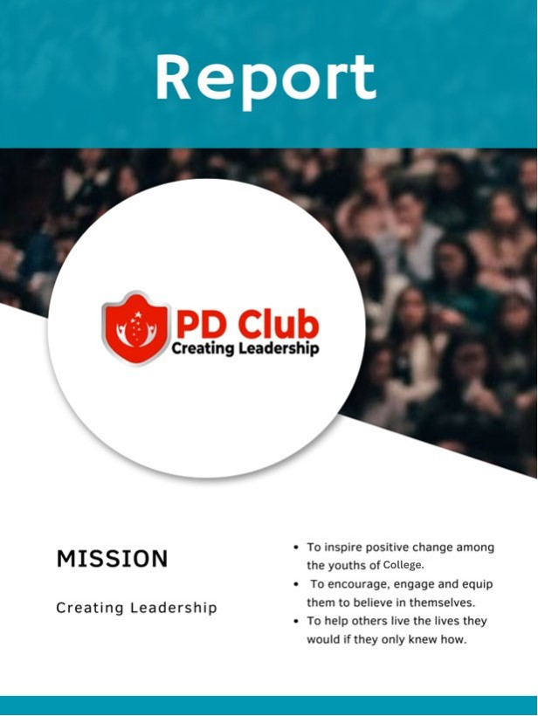

Introduction

The Personality Development Club (PD Club) at Government College of Engineering, Aurangabad, Chhatrapati Sambhaji Nagar, plays a pivotal role in nurturing comprehensive development among students by offering a diverse range of activities focused on improving their character, capabilities, and cultural understanding.

During the academic year 2024-2025, the club has been actively engaged in organizing a plethora of workshops, courses, and camps with the intention of equipping students with skills and insights that extend beyond the boundaries of conventional academic learning. These initiatives are geared towards empowering students to excel not only academically but also personally and professionally

Through these activities, students are provided with opportunities to develop essential life skills, such as effective communication, leadership, time management, and teamwork, which are crucial for their holistic growth and success in various aspects of life. Additionally, the club fosters cultural awareness and appreciation by facilitating interactions and experiences that celebrate diversity and promote understanding among students from different backgrounds.

Faculty Members

The **PD club** is truly honored to be mentored and guided by an exceptional team of dedicated and visionary faculty members. Their unwavering support, wisdom, and leadership have been the cornerstone of our success. With their vast experience and expertise, they not only inspire students but also shape future leaders, innovators, and changemakers

**1. Dr. R. S. Londhe - Faculty Coordinator**

**2. Prof. V. M. Kanke - Faculty Co. Coordinator**

student members

The **PD club** thrives because of its passionate and hardworking student members. Their enthusiasm, creativity, and leadership drive the club forward, making every event and initiative a grand success.

Core Team:

1. Raju Amrute -- President

2. Chaitanya Khole– Vice President

3.Prathamesh Chaudhari – event manger

Activities

|  |  |  |
| --- | --- | --- |
| SR. NO. | Activities | Date |
| 1 | Pantomime show and Guest lecture(Dr. Sandip Lokhande) | 3 October , 2024 |
| 2 | Career Guidance | 4 October 2024 |
| 3 | Public Speaking | 9 October 2024 |
| 4 | Study Seminar | 19 October 2024 |
| 5 | Time Management | 24 October 2024 |
| 6 | python workshop | 19 oct 2024 |

Pantomime show and guest lecture

The academic year commenced with two induction programs focusing on "MIND YOUR MIND" and "PANTOMIME SHOW." These sessions aimed to lay the groundwork for students' personal development journey by delving into topics of self-awareness and life's purpose

* Speaker: - Dr Sandip Lokhande

(Owner of NIMAI Hospital & Youth Guide )

* Venue: -Auditorium hall

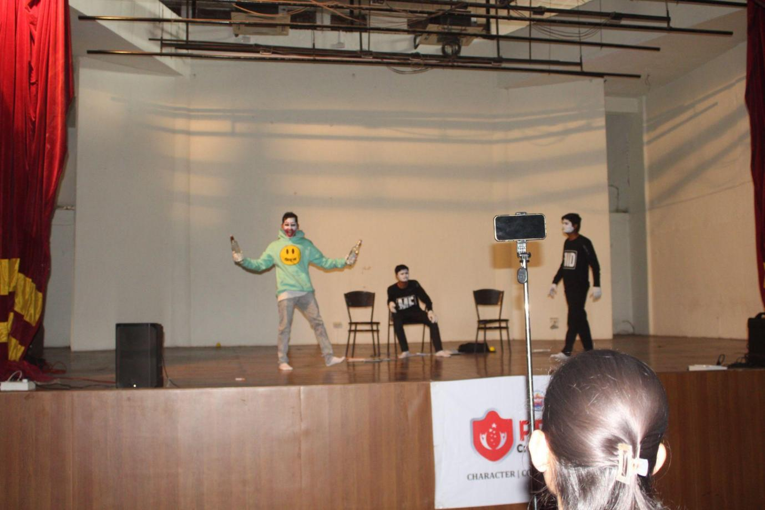

**Pantomime Show**

A pantomime show was performed to raise awareness among students about the mind's deceptive tendencies and how it can lead them astray from their goals. Through expressive movements and silent storytelling, the show illustrated the internal struggle between focus and distractions, with the mind personified as a mischievous character luring the student into procrastination and bad habits. The performance highlighted the importance of self-awareness and discipline, as the student ultimately regained control and refocused on their goal. The show emphasized how mindfulness and determination can help overcome negative influences.

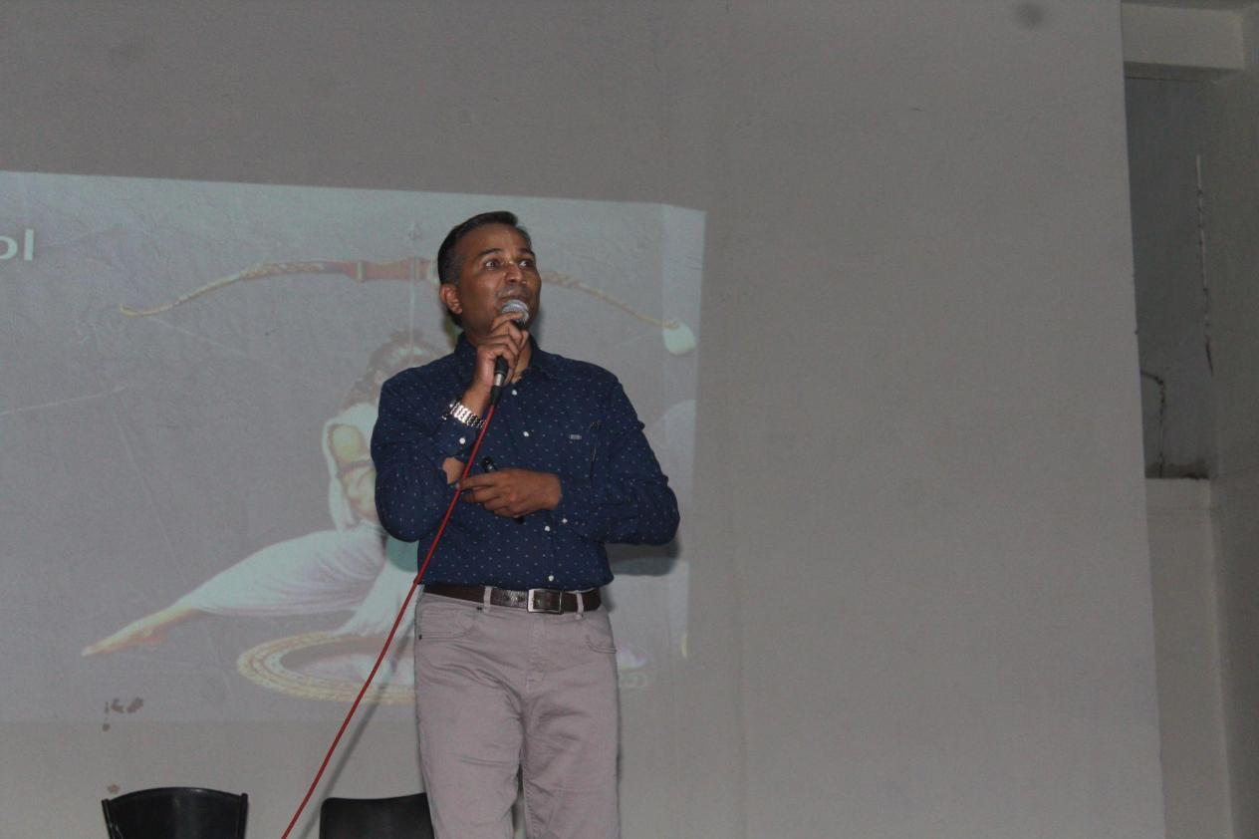

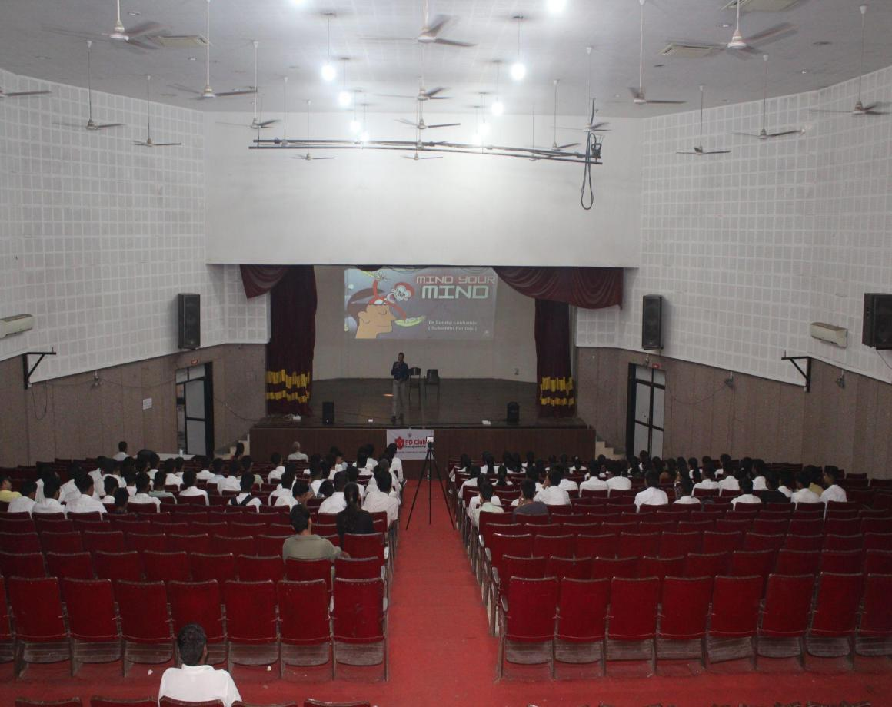

GUEST LECTURE

A guest lecture was delivered by Dr. Sandeip Lokhande, a renowned motivational speaker and life coach with over 15 years of experience guiding youth. Dr. Lokhande provided valuable insights into the mechanisms of the mind, explaining how it can either support or hinder personal growth. He emphasized the importance of cultivating focus and concentration to achieve success in life, sharing practical strategies to overcome distractions and stay on the path toward one’s goals. His engaging and motivational approach left students inspired and equipped with tools to manage their minds effectively for long-term success.

CAREER GUIDANCE

Career guidance helps individuals identify their strengths and align them with suitable career paths, ensuring clarity and direction. It reduces stress by facilitating informed decision-making and enhancing employability through skill development. Ultimately, it fosters confidence and promotes long-term career growth.

* Speaker: - Sachin khandelwal.

(software developer and owner of the Human resource solutions Chh. Sambhaji nagar )

* Venue: -classroom complex

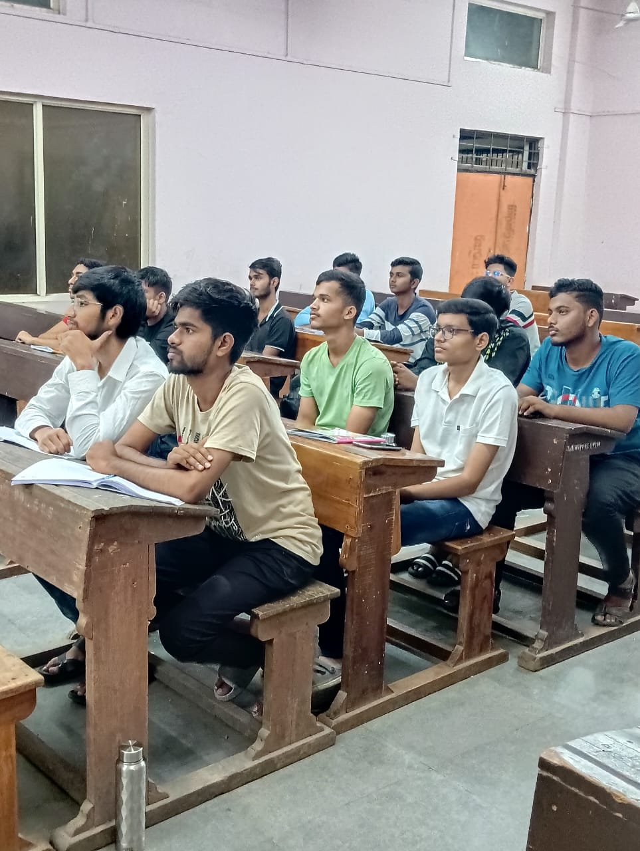

Career guidance is an essential step in shaping a successful future. It helps individuals understand their strengths, interests, and potential, enabling them to choose the right career path. With so many options available today, guidance provides clarity and reduces confusion. It empowers us to make informed decisions and set realistic, achievable goals. By focusing on skill development, career guidance prepares us to meet industry demands and seize opportunities. It also boosts confidence and resilience, helping us tackle challenges effectively. Furthermore, it supports long-term growth by adapting to evolving job markets. Let’s remember, the right guidance at the right time can transform lives. So, let’s embrace this journey of self-discovery and preparation to build a fulfilling career. Thank you!

PUBLIC SPEAKING

Public speaking is the art of expressing ideas and communicating effectively in front of an audience. It builds confidence, enhances communication skills, and helps influence and inspire others. Mastering this skill is essential for personal and professional growth.

* Speaker: -Sachin khandelwal.

(software developer and owner of the Human resource solutions Chh. Sambhaji nagar )

* Venue: -classroom complex

Public speaking is a powerful skill that can transform both personal and professional lives. It’s not just about speaking; it’s about connecting, inspiring, and influencing others. Mastering public speaking boosts confidence and sharpens communication skills. It allows us to express ideas clearly, making a lasting impact on our audience. Whether in meetings, interviews, or presentations, strong public speaking can open doors to endless opportunities. It also helps in overcoming the fear of addressing a crowd and builds self-assurance. Remember, every great speaker was once a beginner. So, embrace the stage, practice relentlessly, and let your voice be heard. Public speaking isn’t just a skill—it’s a superpower!

### **Activities done by the club**

#### **1. Storytelling Practice**

* Share a personal story or experience with a group.
* Emphasize emotions, expressions, and keeping the audience engaged.

#### **2. Group Discussions**

* Participate in discussions on current topics with peers.
* Learn to present arguments clearly and respond to others.

#### **3. Debate Sessions**

* Engage in friendly debates to improve reasoning and persuasive speaking.
* Learn to think critically and defend your viewpoint effectively.

STUDY SEMINAR

A study seminar is a powerful tool for enhancing learning and collaboration. It allows participants to dive deeper into subjects, exchange ideas, and gain new perspectives through discussions. By fostering critical thinking and teamwork, seminars prepare us for academic and professional success.

* Speaker: -Dhananjay joshi

(owner of Paramanu classes)

* Venue: -classroom complex

This study seminar is opportunity to deepen our understanding of a subject. It encourages active learning, critical thinking, and collaboration with peers. Through discussions, we gain new perspectives and insights that textbooks alone can’t provide. Seminars also improve our communication and presentation skills, preparing us for future professional environments. They help us clarify doubts and strengthen our knowledge base. Additionally, they foster teamwork and problem-solving abilities, which are crucial in any field.

TIME MANAGEMENT

Time management is the key to achieving our goals efficiently and effectively. It helps prioritize tasks, reduce stress, and maintain a balance between academics, work, and personal life. Mastering time management allows us to make the most of every moment and stay on track toward success.

* Speaker: - Dr Sandip Lokhande

(Owner of NIMAI Hospital & Youth Guide )

* Venue: classroom complex

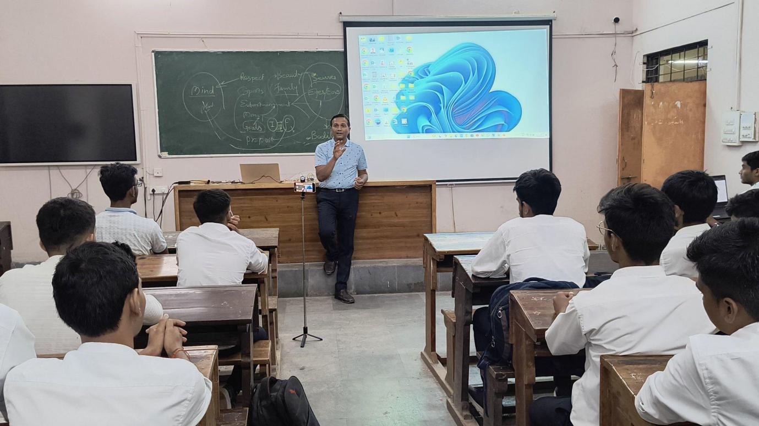

Time management is the key to achieving success in any aspect of life. It allows us to prioritize tasks, ensuring that we focus on what truly matters. By managing our time effectively, we can reduce stress and work more efficiently. Good time management improves productivity and helps us balance personal and professional commitments. It also fosters discipline and better decision-making, which are essential for long-term success. Remember, time is a limited resource, and how we use it defines our achievements. Procrastination steals opportunities, but proper planning creates them. Let’s value our time and make every moment count. As the saying goes, “Time is money,” so let’s invest it wisely.

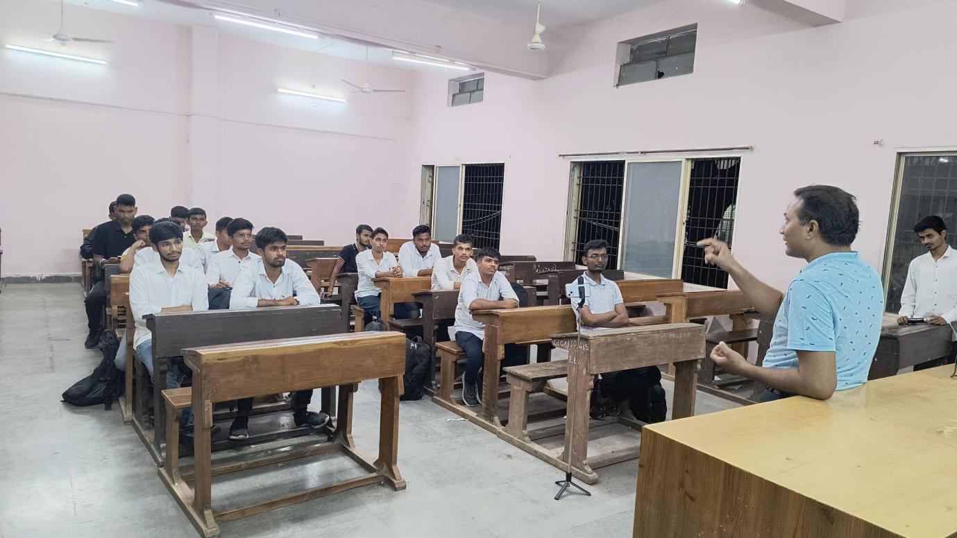

python workshop

A **Python workshop** is a structured training session where participants learn Python programming, ranging from basics to advanced topics. These workshops are useful for students, developers, and professionals looking to enhance their coding skills.

* Speaker: - vedang kawalkar

(alumni of GECA )

* Venue: -classroom complex

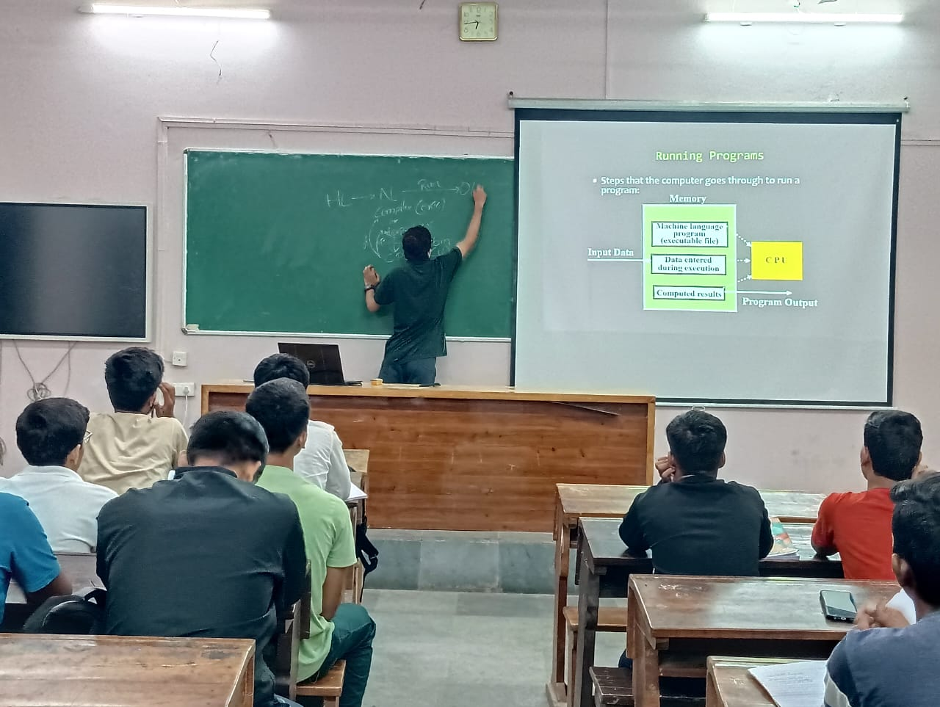

This workshop provides hands-on learning, allowing participants to practice coding in real-time and understand concepts effectively. In the workshop, you can clear your doubts and gain insights into industry practices. Additionally, it offers networking opportunities, enabling participants to connect with professionals and collaborate on real-world projects.

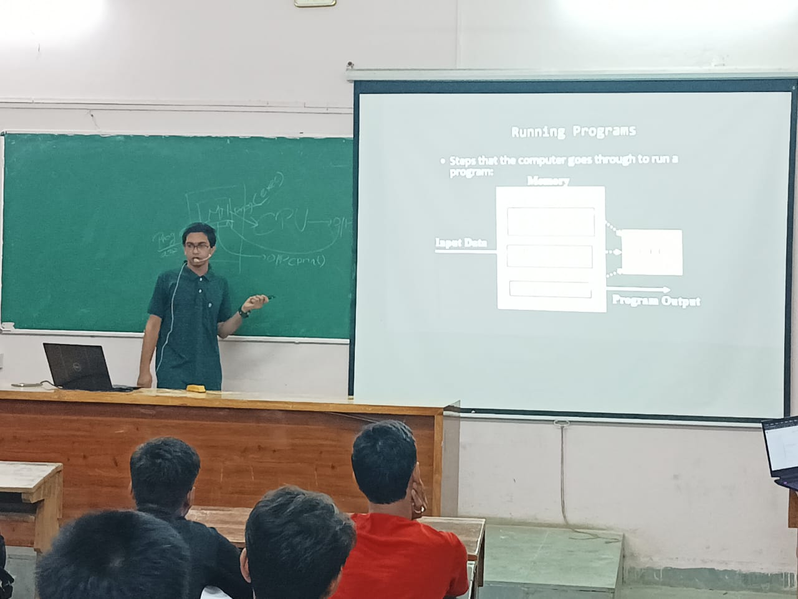By the end of the workshop, participants will have a strong foundation in Python and practical experience in coding. This will help them apply their knowledge to real-world projects and enhance their career opportunities.